**The Final Voyage of SSV Dionysus**

***Fast-Paced Futuristic Space Sailing***

**Pleiades Project**

**Deandra Brown**

**Anusha Rao**

**Ayselah Smith**

**Logan Smith**

**Joey Tse**

**By signing below, you are agreeing to not disclose any information inside of this document to any third parties.**

Confidential Disclaimer: ___________________________________________________

**Company Info**

**Developer Contact Information:**

Deandra Brown -- Art Assets, UI Design -- dbnine6@ufl.edu

Digital Arts and Sciences student at the University of Florida

Anusha Rao -- Art Assets, Art Concept -- anusha.rao@ufl.edu

Digital Arts & Sciences major at University of Florida

Ayselah Smith -- Programming & 3D Modelling -- ayselahsmith@ufl.edu

Student at University of Florida pursuing a degree in Digital Arts and Science.

Logan Smith -- Programming & Game Direction -- loganda.smith@ufl.edu

UF Gator pursuing a Computer Science degree

Joey Tse -- Programming & Level Design -- jtse1@ufl.edu

Student at University of Florida pursuing a degree in Digital Arts and Science.

**Game Description**

Genre: Sci-fi Action/Adventure

Planned Release: April 29th, 2020

Platforms: Steam and Windows Store

Inputs: Keyboard & Mouse

Monetization Plan: $19.99 for base game with possible DLC based on reception

The game “The Final Voyage of SSV Dionysus” is a Sci-fi Action/Adventure shooter game that takes you on a journey through multiple galaxies. This game features a single-player story mode in which you play as an astronaut lost in space. It’s your job to navigate through space and find your way home.

**Game Design**

**Features:**

* Realistic spacecraft control,
* Varied enemy behavior and obstacles
* Random ship customization so every playthrough is unique

**Gameplay Modes:**

Single Player Story Mode

**Unique Selling Points:**

A key feature of this game will be the development of the characters on board the ship, and the dialogue system between these crew members. The conversations between characters will serve as storytellers to explain the backstory of why they are at their position within the game’s storyline. The dialogue will also narrate major events in the game. This makes the game more immersive and engaging.

Special Mechanics:

* Bullet Hell Boss Fights
* Black Hole Obstacle - Warped off of the dimension
* Space Combat- Following Mouse
* The Dialogue between the crew members influences/ precurses scripted events in the game.

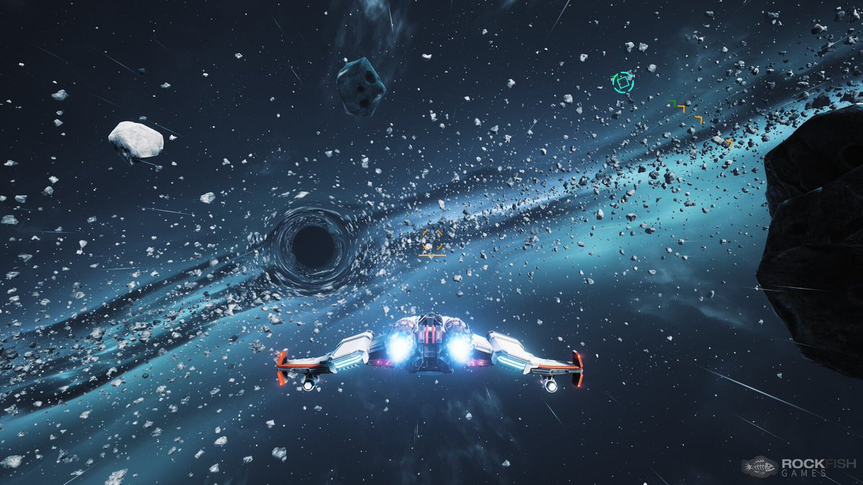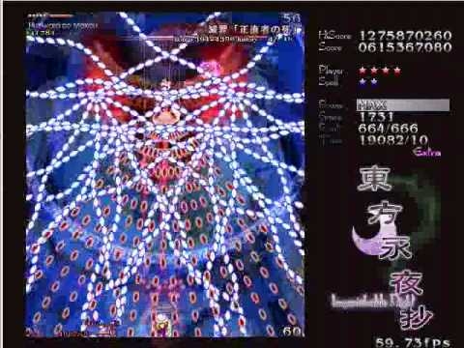

**Scope:**

* 5 minute game
* There are 5 levels
* The main Player is an astronaut whose crew has gotten shipwrecked while on a space mission.
* As a player, you need to move through 5 dimensions in order to get back to your dimension and return home with your crew.
* There is one playable character but at the end of each level, there is the option to take a new ship customization to replace the current ship.

**Game Comfort Level:**

We have no plans to bring this game to Virtual Reality and we do not believe its gameplay is conducive to the format.

**Game Loop:** 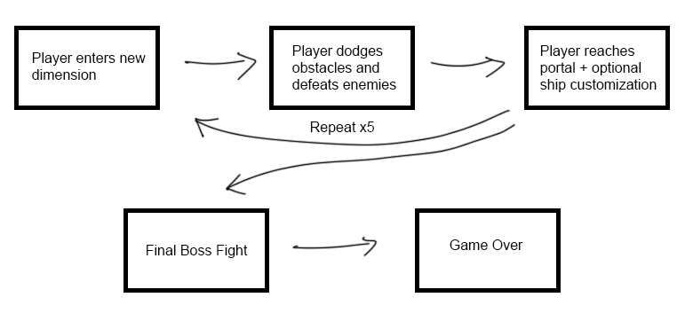

**Mood Board**

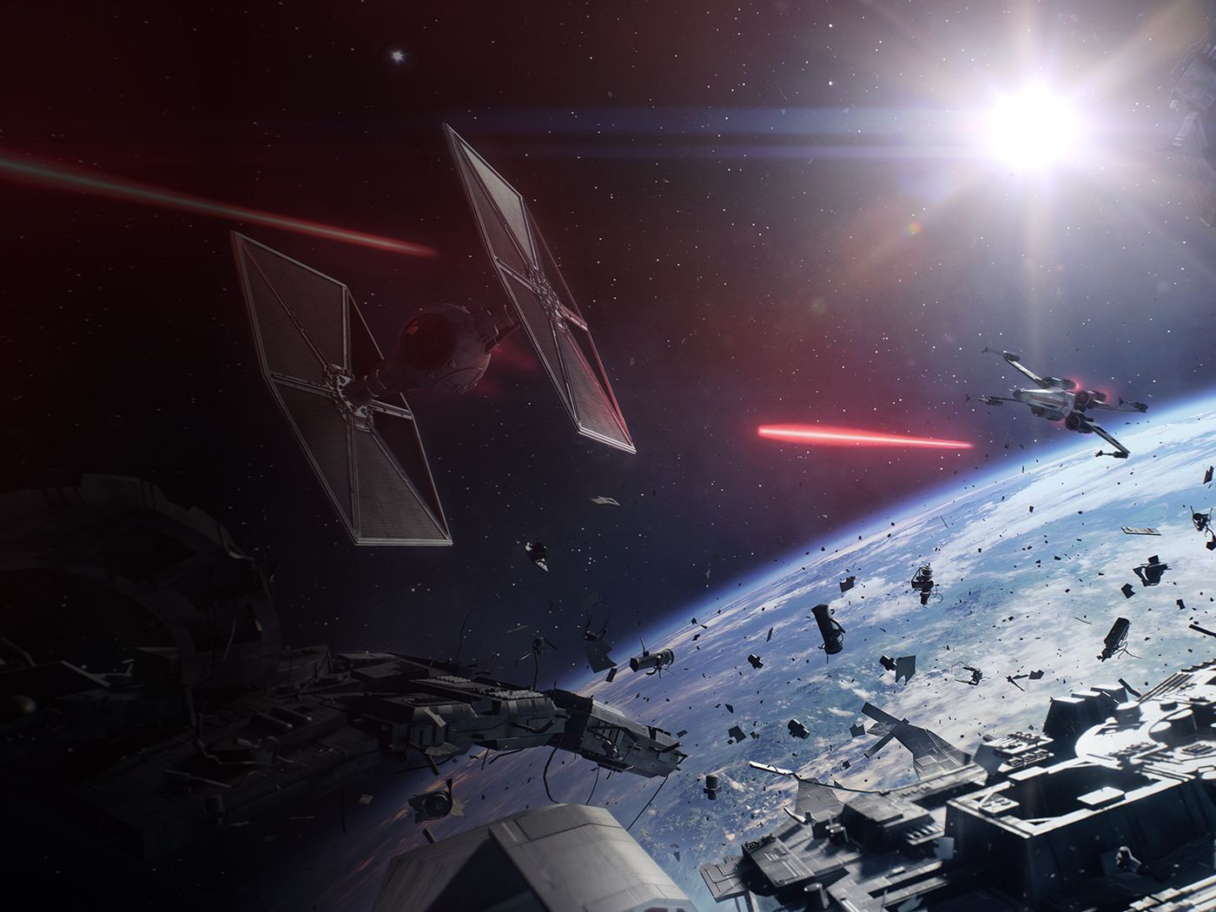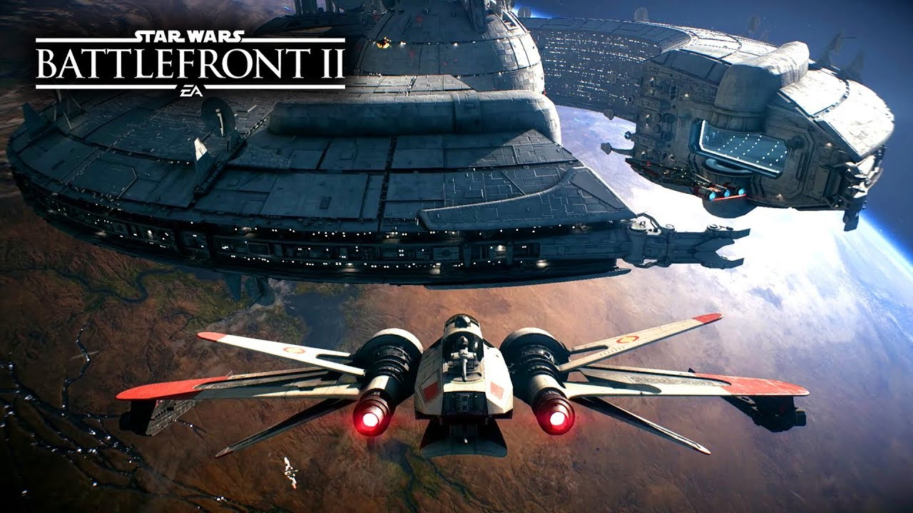

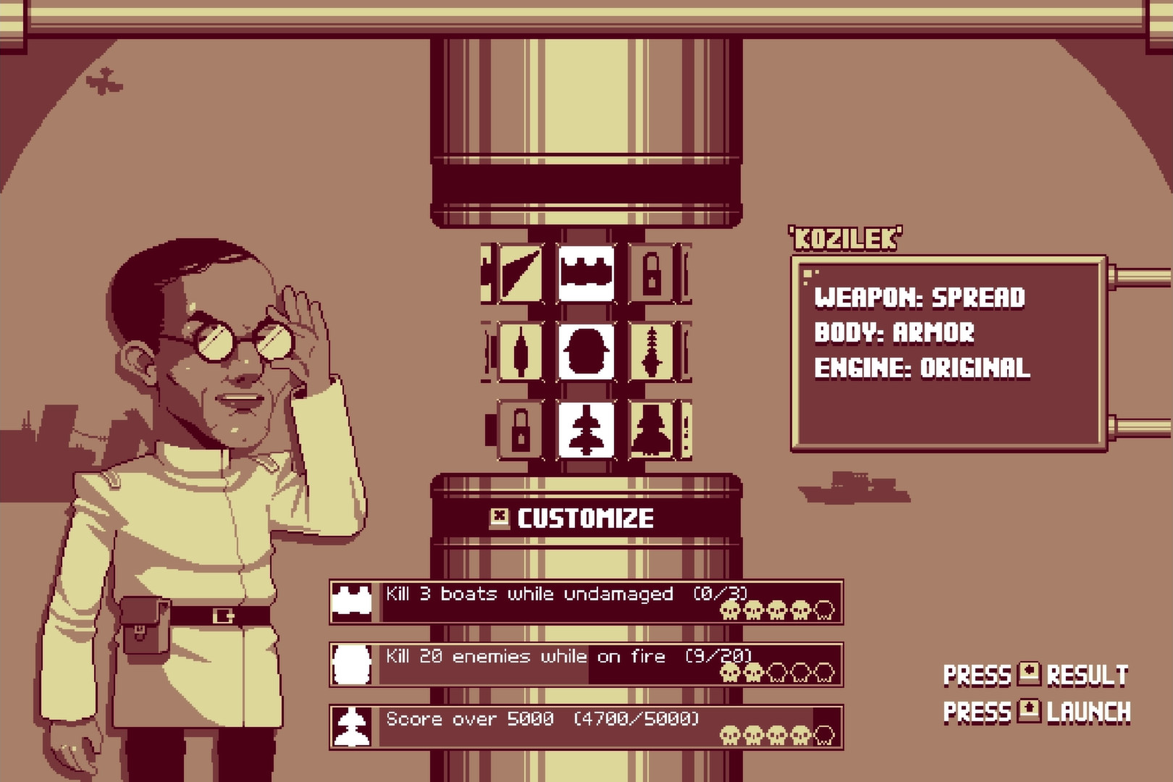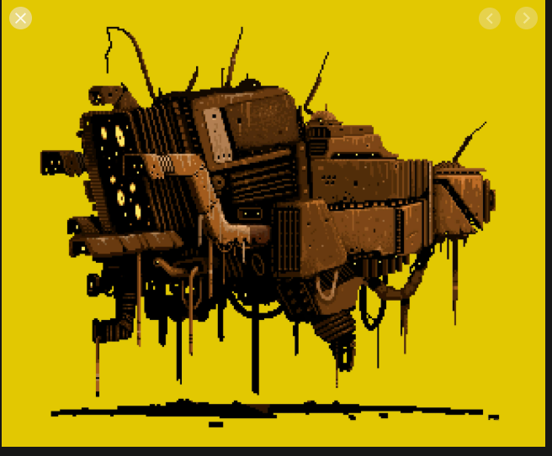

**Ideal User Profiles**

* Age range for Users: 12 and up
* Amber enjoys Dialogue-driven games such as Undertale and Fire Emblem: 3 Houses.
  + For this player, our game features a rich story told through dialogue and interactions between the crew members.
* Ethan is a big fan of bullet hell games like Binding of Issac and Touhou Project and has always wanted to see how such games would play out in 2.5D.
  + For this player, our game offers a real challenge, even for veterans of the genre.

**Milestone Schedule**

|  |  |  |
| --- | --- | --- |
| Milestone | Date | Description |
| 09 | 03/13 | GDD/Game Idea Pitch |
| 10 | 03/20 | Also GDD - Project Roadmap |
| 11 | 03/27 | Alpha Milestone |
| 13 | 4/10 | Beta Milestone |
| 15 | 4/24 | Gamma Milestone |

You and your trusty team, Pleiades, boarded the SSV Dionysus two light years ago on a mission to end the colonisation of the planetoid Sedna (90377). You were successful in breaking up the war, but had to flee the planet when Orpheus the Space Lord, who is taking over the entire universe, discovered your coup. What you didn’t know was that he would banish you to eternal wandering through the galaxies. However, your team is determined to go home. As you travel through the dimensions between your location and your home, you must attack and defeat enemy ships, as well as fight aliens at the end of each portal.